PRESS REGISTRATION (non-transferable)

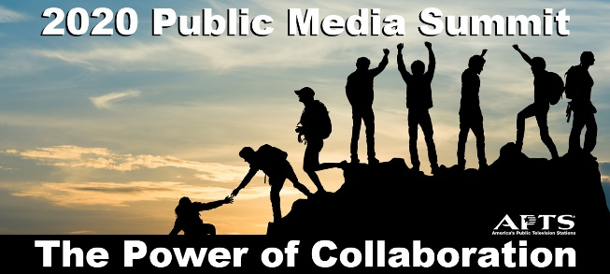

APTS 2020 Public Media Summit
February 24-26, 2020
The Ritz-Carlton Washington, D.C. Hotel
1150 22nd Street, NW Washington, D.C.

Visit www.apts.org/events for schedule and other 2020 Public Media Summit information.

Registrant Information
Valid press credentials required for entry.

Name:
(Print name as it should appear on badge and on participants list)

Title:

Organization:

Street Address:

City / State / Zip:

Email / Phone:

If you have any special needs or accommodations, please provide details below:

Registrant Events

Registration includes the following events. Place a check next to each event you plan to attend.

□ Monday, February 24, Lunch
□ Monday, February 24, Reception
□ Monday, February 24, Dinner
□ Tuesday, February 25, Breakfast
□ Tuesday, February 25, Lunch
□ Tuesday, February 25, Dinner

□ Wednesday, February 26, Capitol Hill Breakfast

Please complete and return by Friday, February 7, 2020 to:
Stacey Karp, APTS
Email: skarp@apts.org; Fax: 202-654-4236

